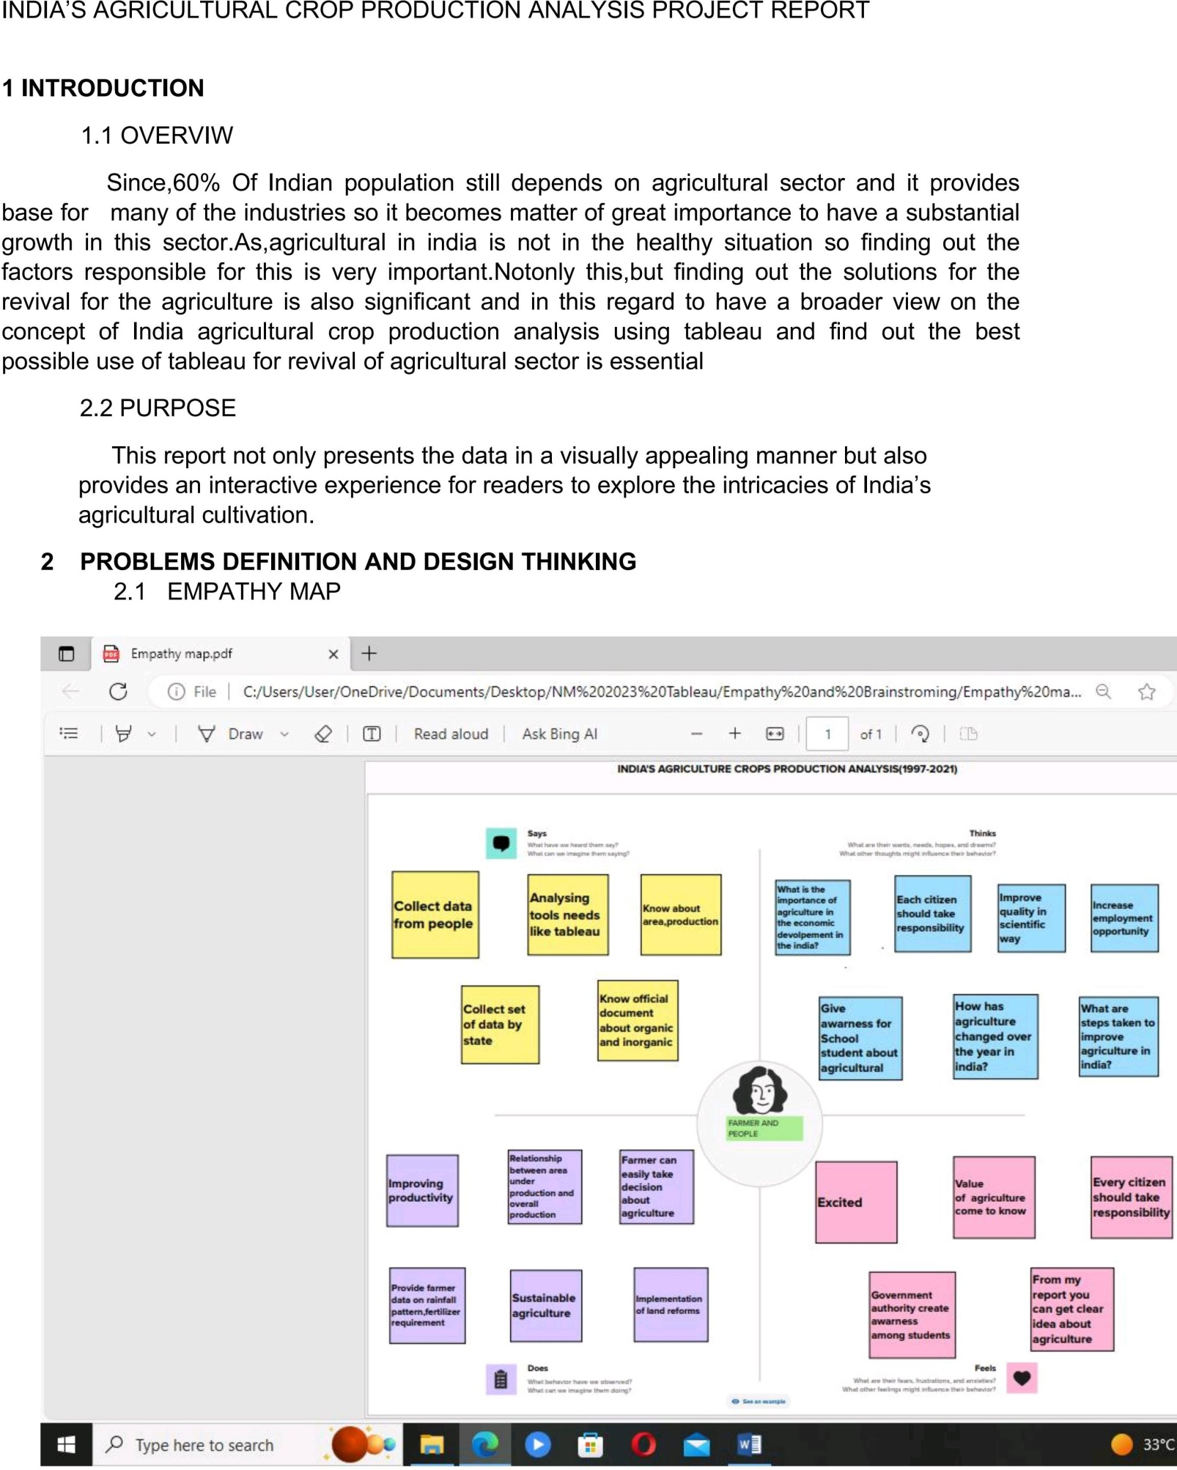

**INDIA’S CROP PRODUTION ANALYSIS PROJECT REPORT**

